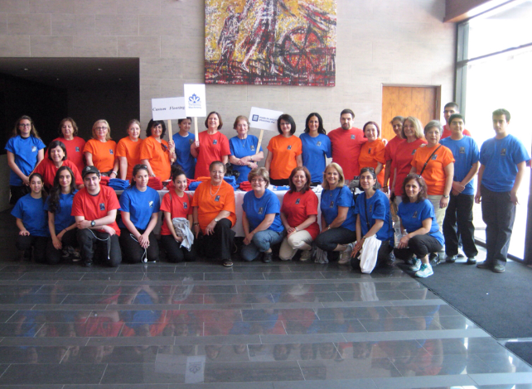
ARS Toronto Roubina Chapter - Annual Walkathon

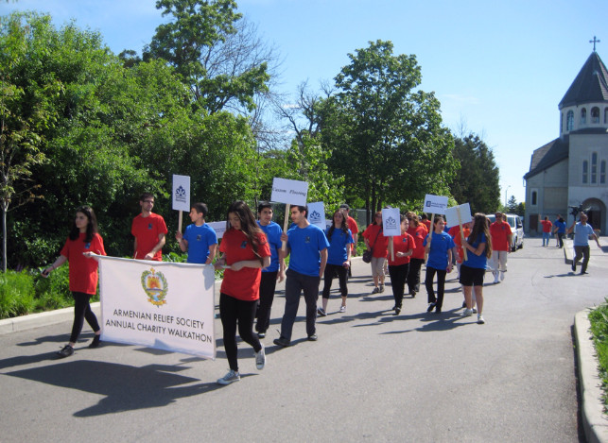
ARS Toronto Roubina Chapter's Annual Walkathon took place on Sunday June 1, 2014. There were over 40 enthusiastic people who participated and helped collect donations. Proceeds will go to the ARS Mor Mankan Clinic in Akhoorian, Armenia and towards other ARS initiatives. We are looking forward to next year's walkathon!
